“In the name of the God of the rainbow” …

For Kian Pir Falak, the 10-year-old child who was shot on 16th Nov. 2022 in southern part of Iran in the protests of “Women- Life- Freedom”

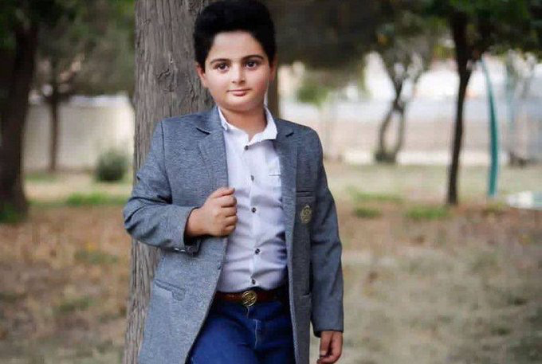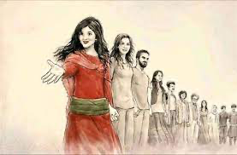

Over the last nine weeks, protests have erupted in Iran following the death of Iranian Kurdish woman, 22-year-old, Mahsa Amini in police custody for allegedly breaching strict dress rules for women. At least 348 protesters have been killed and 15,900 others arrested in a crackdown by security forces, 41 children are among them too. For many, death sentences linked to recent protests are being issued. Kian Pir Falak, was the 10 year old boy killed yesterday in Izeh in Southern part of Iran.

“Men and women of various ethnic backgrounds have marched under the banner of women’s rights. Across Iran crowds have shouted the women’s movement chant in both Kurdish “Jin, Jian, Azadi!” and in Farsi “Zan, Zendagi, Azadi!,” which means “Woman, Life, Freedom!,” understanding that freedom for women means freedom for all.

You migrate from your country, but your country doesn’t migrate from your soul. Many Iranians across the world are experiencing anger, anxiety, and sadness, they are exhausted and distracted. Being faraway and witnessing and seeing cruelty and brutality, while you tell yourself all the time that it could be you, yourself for a loose scarf being arrested and killed. It could be your dearest to be shot completely innocent. And your hands are empty, they are not full enough to help not only your family but also your bigger family of 80 million of people there.

Different countries globally, get different reactions in the support of this movement and condemning the Iran government’s actions. However, due to oil and gas crisis, many governments are not supporting the movement as they must to be able to consider negotiations on the nuclear deal. In between of all these political plays, children, young women, and students are losing their lives these days in the streets of Iran while asking for their very basic rights as life and freedom (see this video and look at all these young hopeful eyes and faces that are not mang us any more to sing and dance)

At the University level, many universities in the world have reflected on these protest and movement, such as University of St Andrews, Durham and UCL just in the UK.

The pain to review the news and reflect on it, honestly, was and is more than my capacity, and I am going to get help from my therapist to be able to manage all the tough emotions I am experiencing. However, the death of the 10 year old Kian, was something I couldn’t keep silent and pass, I should write about it as I always did to inform the world- at the scale of my empty hands- about what is happening in Iran behind its closed doors to media and International organisations. This is his video, in which he is showing his invention that he is going to compete with it in a national completion. He started with “ In the name of the God of the rainbow”…

Maryam Lotfi
17 Nov. 2022

Links to videos:
https://www.youtube.com/watch?v=MacA8xHGfrQ
https://www.youtube.com/watch?v=Er3MoJEr_m0

https://www.bbc.co.uk/news/world-middle-east-63648629
https://edition.cnn.com/2022/11/14/middleeast/iran-protests-first-death-sentence-intl/index.html
https://news.st-andrews.ac.uk/archive/women-life-freedom/
https://www.durham.ac.uk/research/institutes-and-centres/advanced-study/about-us/events/women-life-freedom-or-what-are-the-iranians-dreaming-about/
https://www.ucl.ac.uk/bartlett/igp/events/2022/oct/women-life-freedom-iran-uprising-its-international-impact

